Assignment-1(AI ML)

1.Write a python program to calculate the area of a rectangle given its length and width.

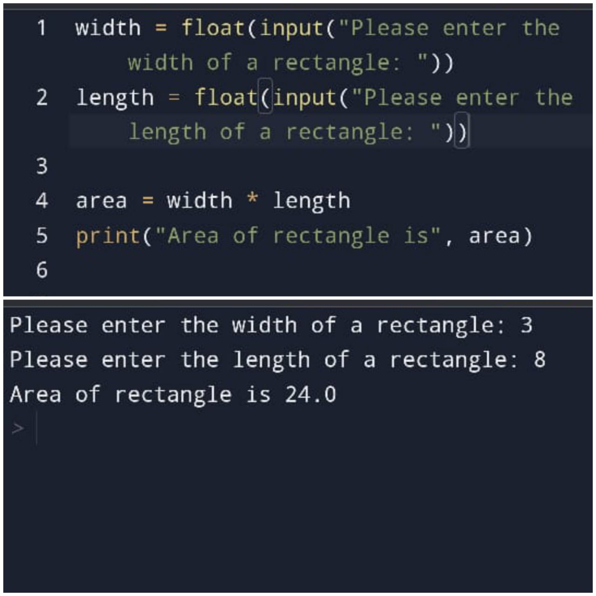

2.Write a program to convert miles to kilometres

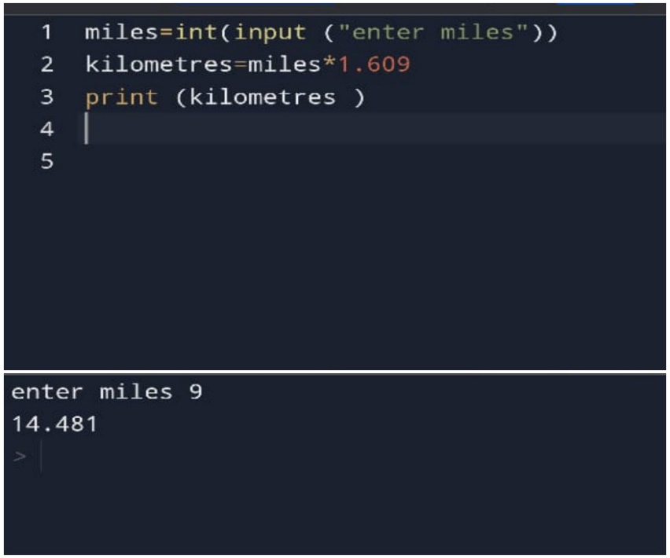

3.write a function to check if a given string is palindrome44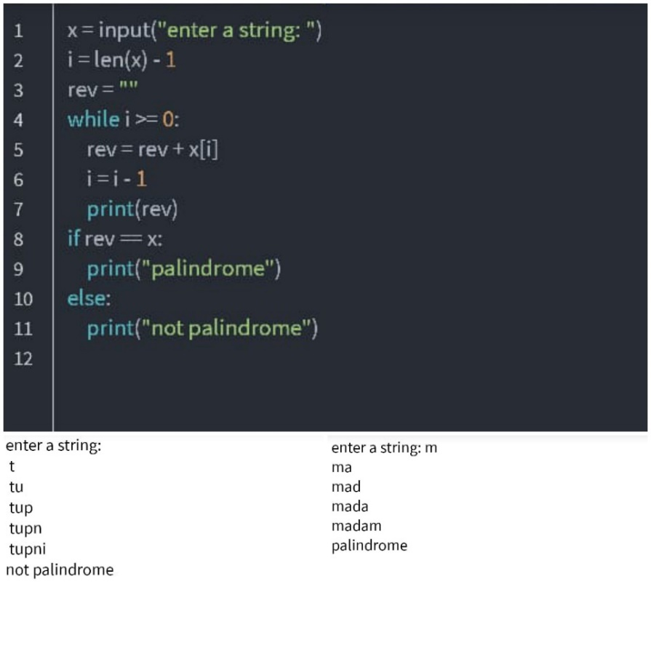

4.Write a python program to find the second largest element in a list

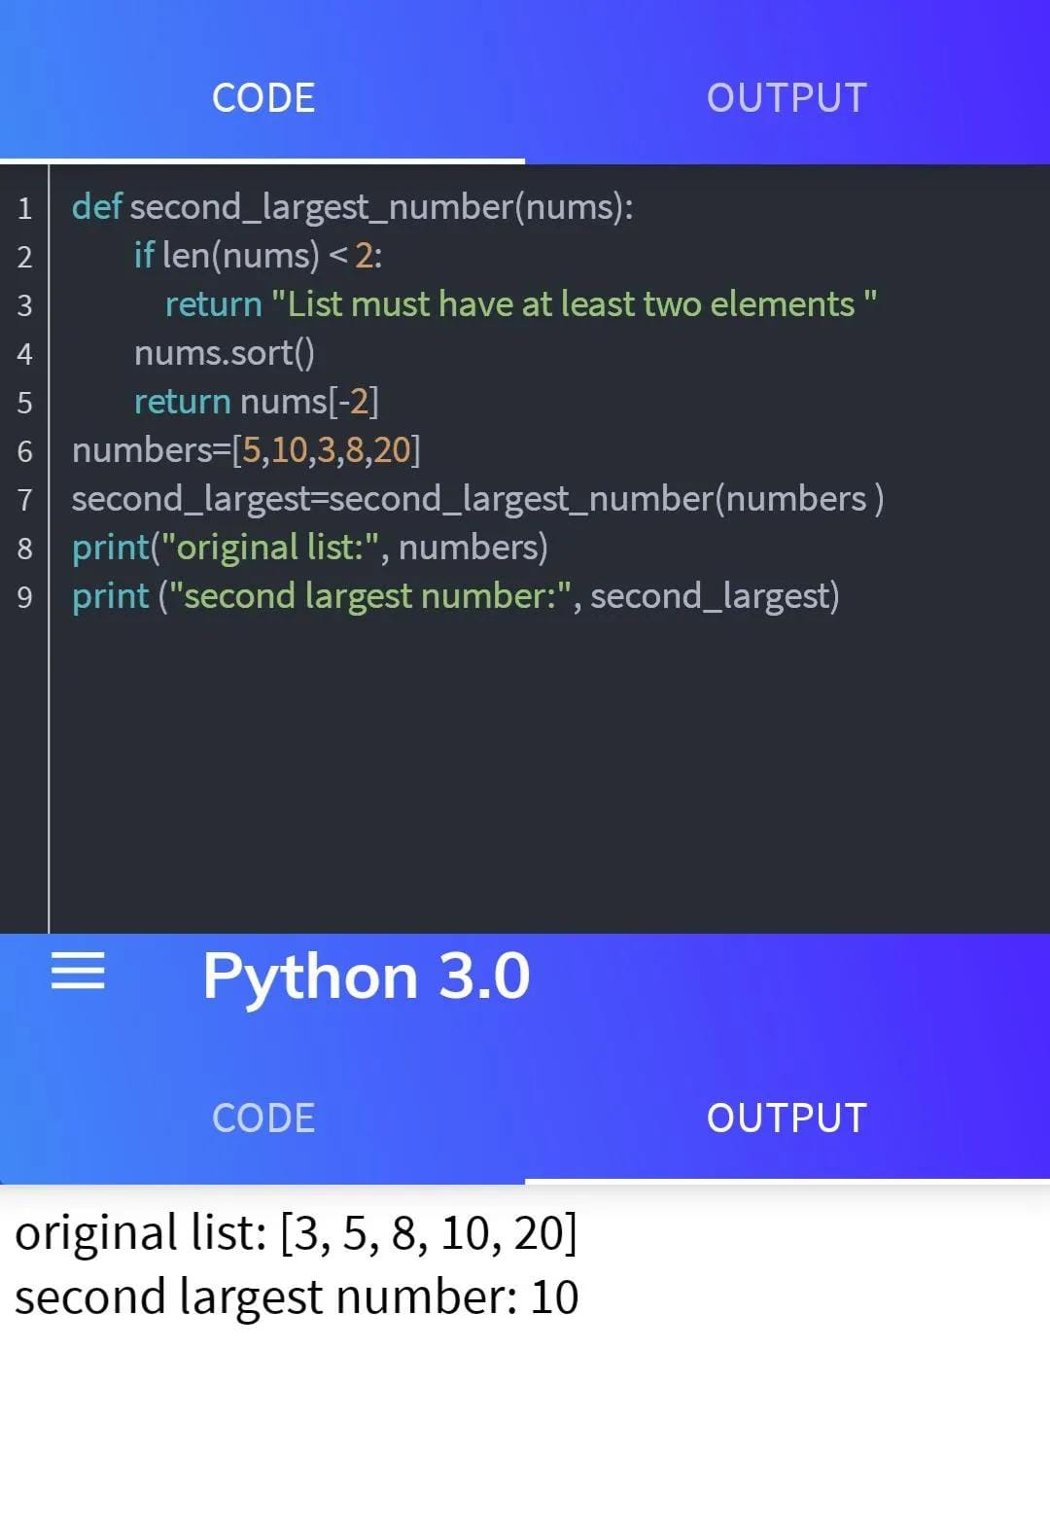

5.Explain what indentation means in python.

A] In python, indentation is fundamental aspect of a language is syntax and plays a crucial role in defining the structure and organization of code. Consistent indentation is crucial for python as it replaces traditional curly braces {} used in other programming languages for defining block of code.

6.write a program to perform set difference operation

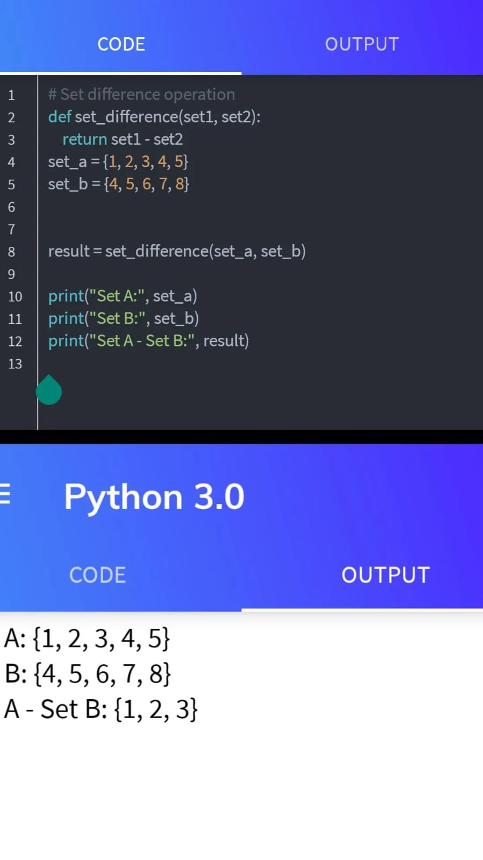

7.Write a python program to print numbers from 1to 10 using a while loop.

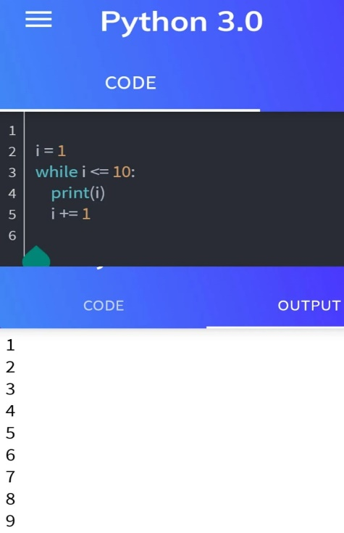

8.Write a program to calculate the factorial a number using a while loop.

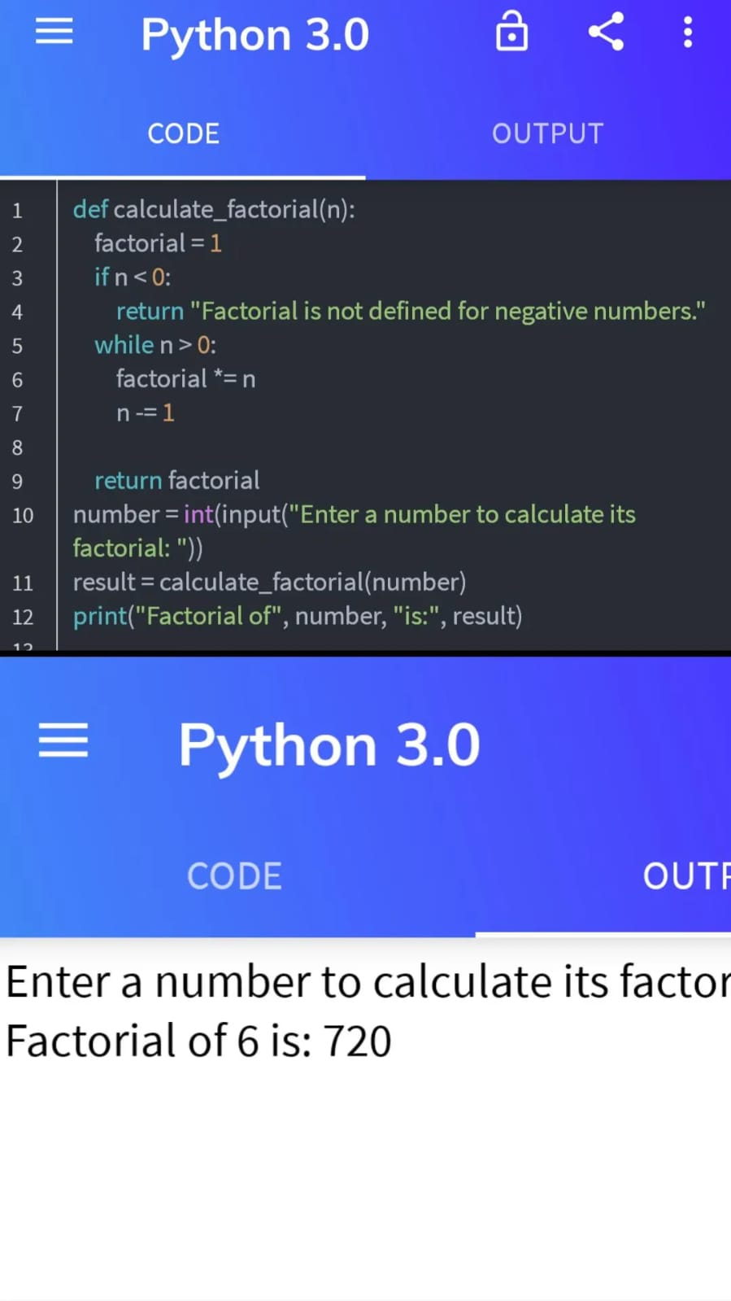

9.Write a python program to check if a number is positive, negative, or zero using if-elif-else statement.

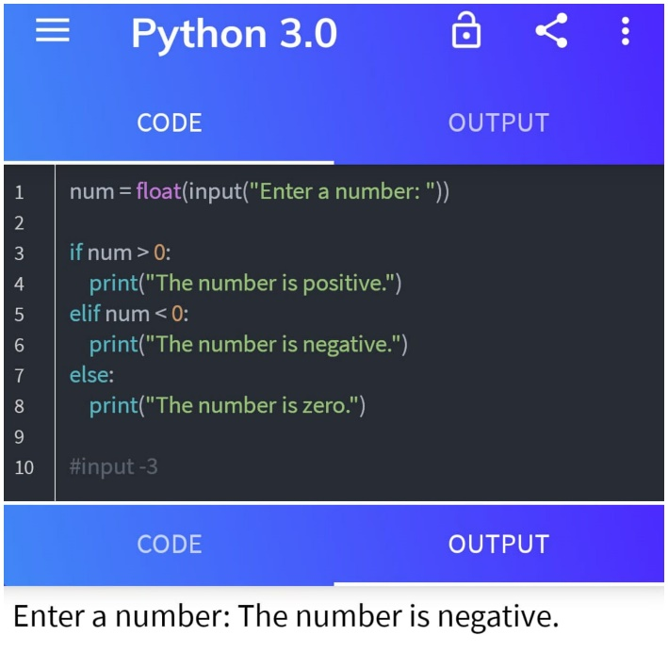

10.Write a program to determine the largest among three numbers using conditional statements.

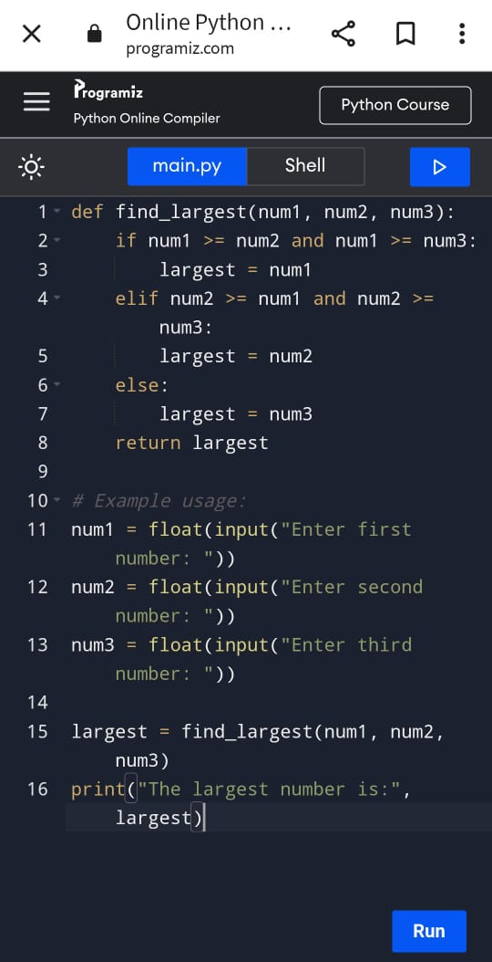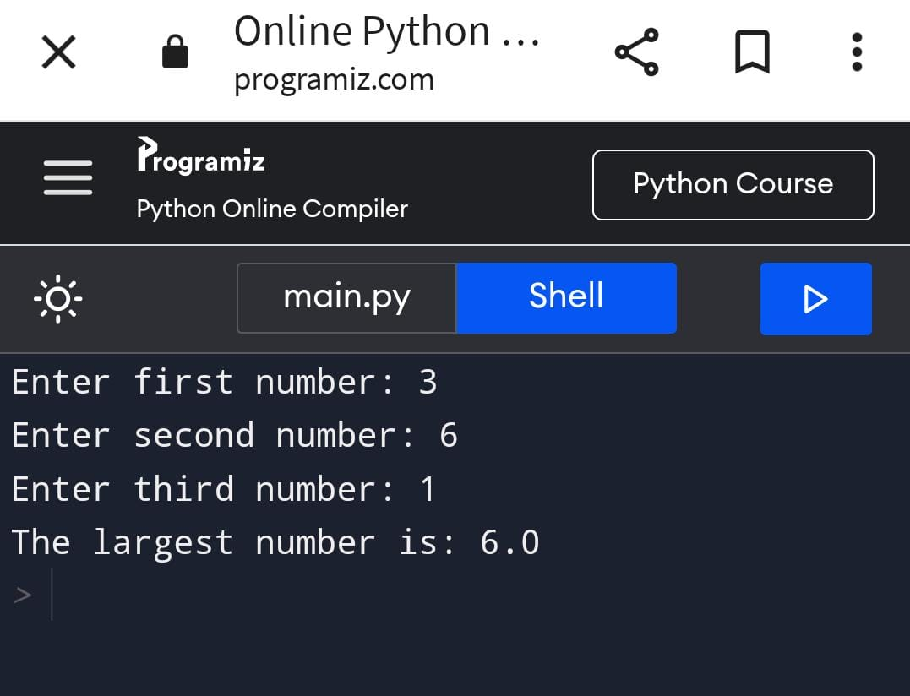

11.Write a python program to create a NumPy array filled with ones of given shape

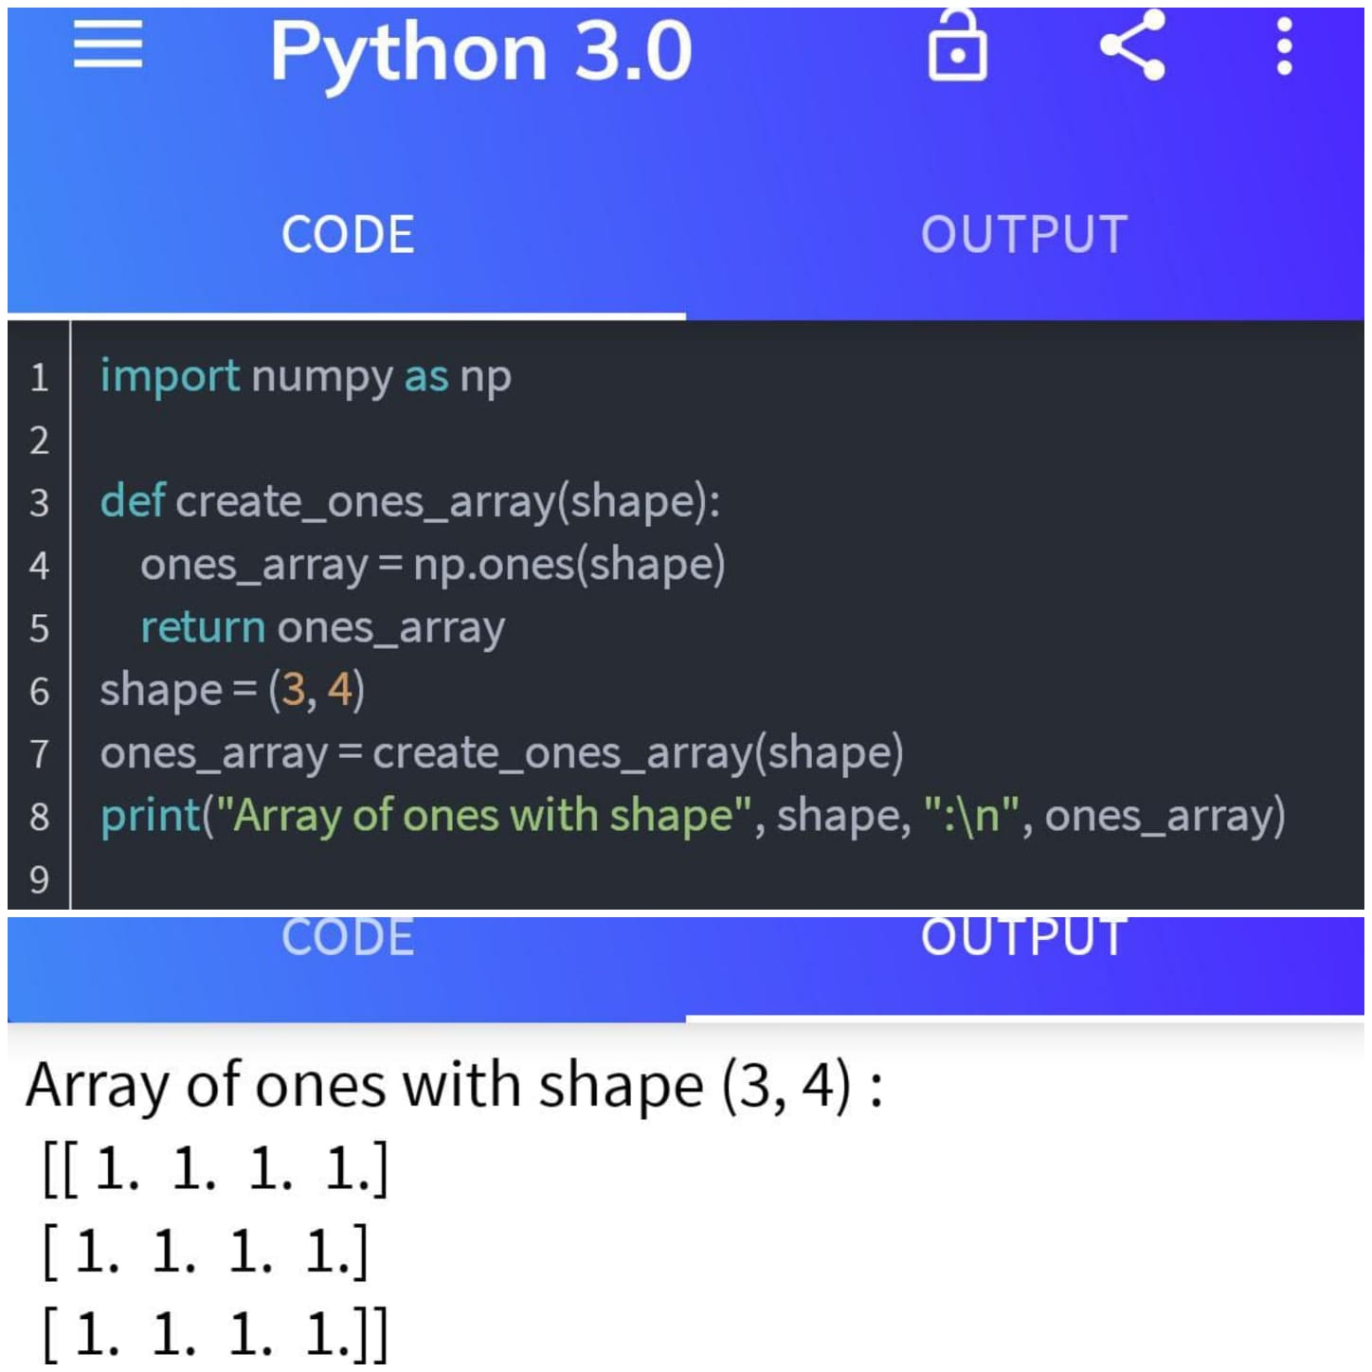

12.Write a program to create a 2D NumPy array initialized with random integers.

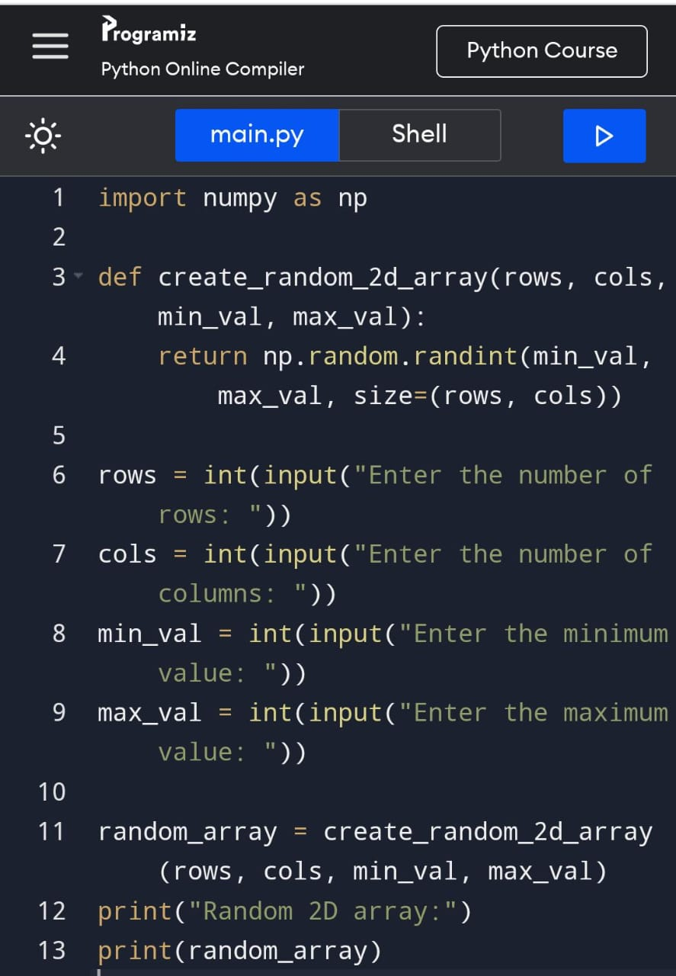

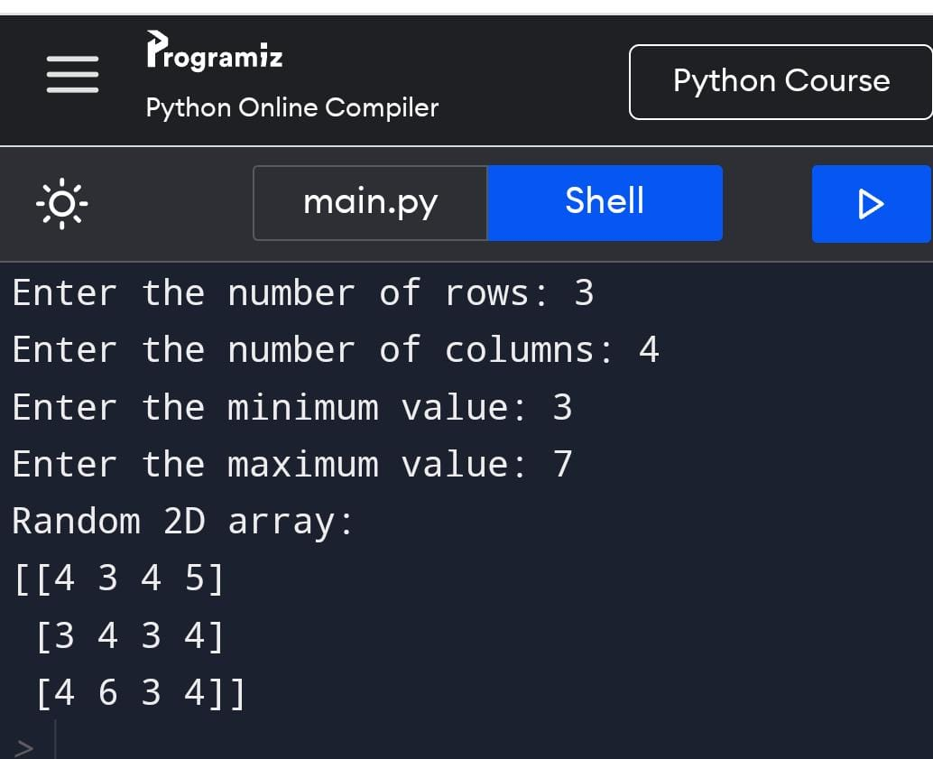

13.Write a python program to generate an array of evenly spaced numbers

Over a specified range using Lin space.

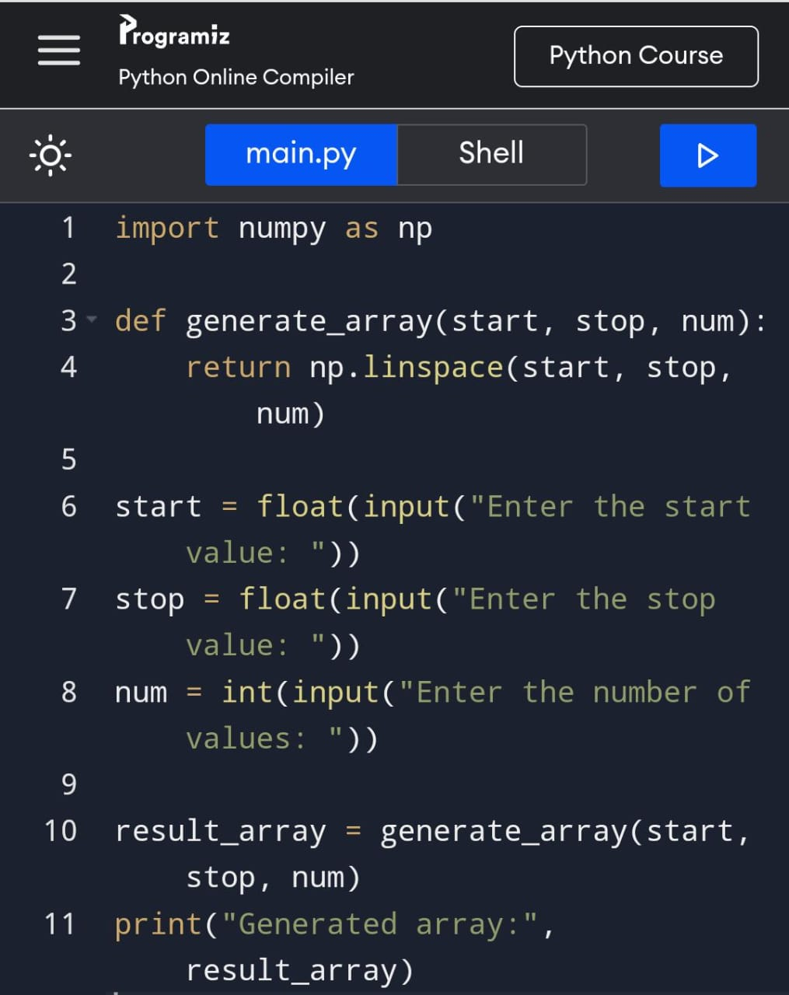 

14.Write a program to generate an array of 10 equally spaced values between 1 and 100 using Lin space.

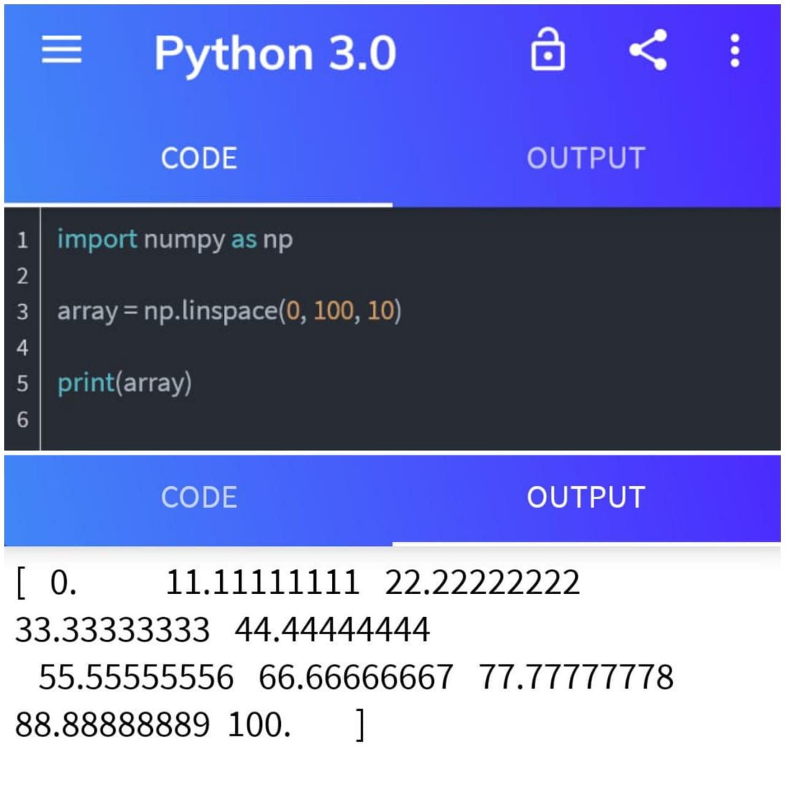

15.Write a python program to create an array containing even numbers from 2 to 20 using arrange.

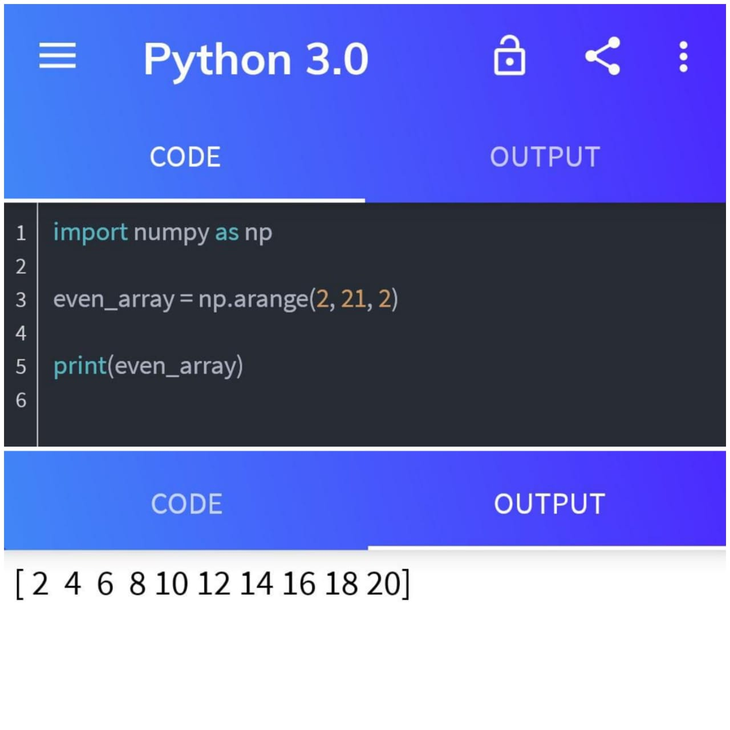

16.Write a program to create an array containing numbers from 1 to 10 with a step size of 0.5 using arrange.

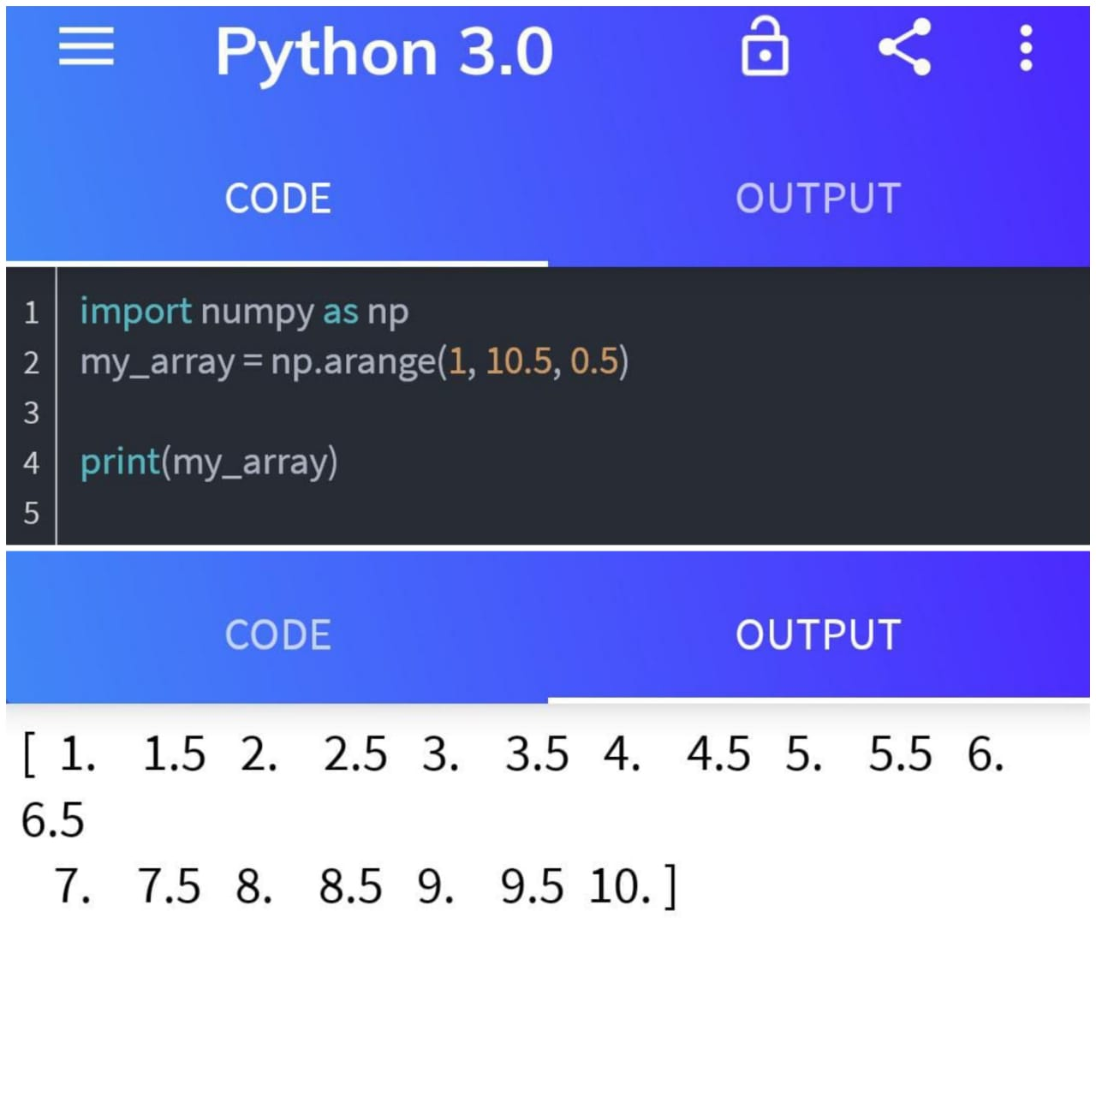

Submitted by,

Kakarla Lavanya

20AJ1A0462

Amrita Sai institute of science

and technology, paritala.